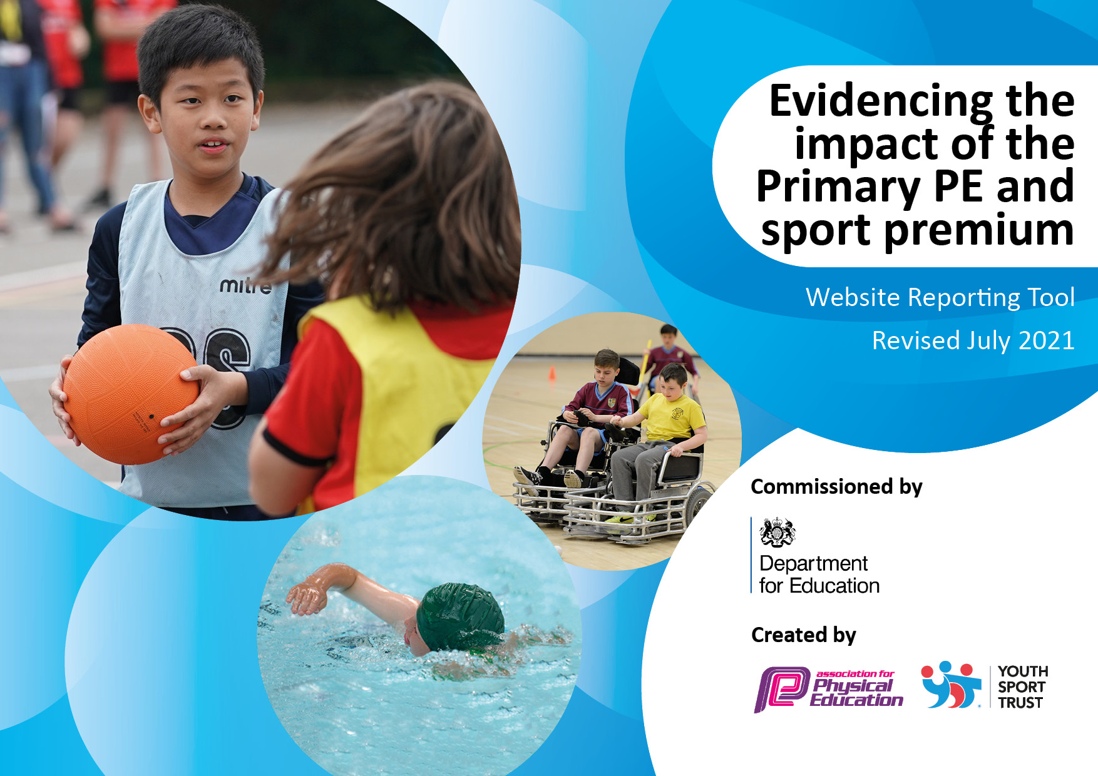
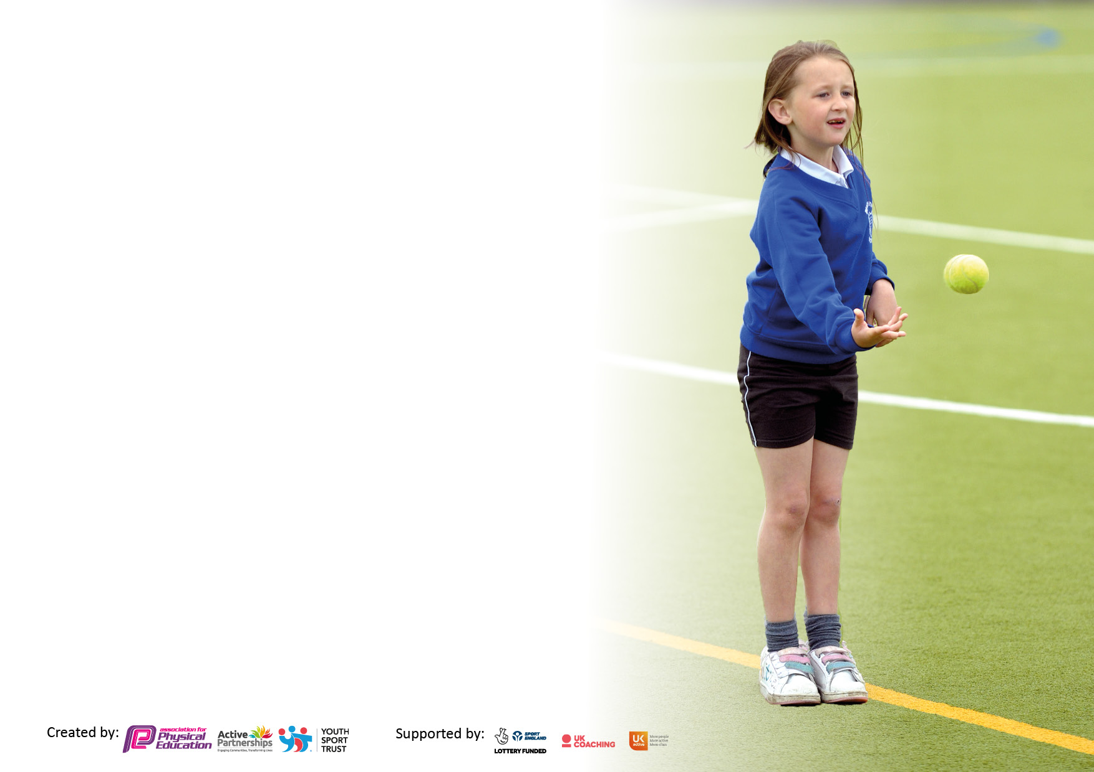

It is important that your grant is used effectively and based on school need. The Education Inspection Framework makes clear there will be a focus on ‘whether leaders and those responsible for governors all understand their respective roles and perform these in a way that enhances the effectiveness of the school’.

Under the Quality of Education Ofsted inspectors consider:
Intent - Curriculum design, coverage and appropriateness
Implementation - Curriculum delivery, Teaching (pedagogy) and Assessment
Impact - Attainment and progress

To assist schools with common transferable language this template has been developed to utilise the same three headings which should make your plans easily transferable between working documents.

Schools must use the funding to make additional and sustainable improvements to the quality of Physical Education, School Sport and Physical Activity (PESSPA) they offer. This means that you should use the Primary PE and sport premium to:

- Develop or add to the PESSPA activities that your school already offer
- Build capacity and capability within the school to ensure that improvements made now will benefit pupils joining the school in future years
- The Primary PE and sport premium should not be used to fund capital spend projects; the school’s budget should fund these.

Pleasevisitgov.ukfortherevisedDfEguidanceincludingthe5keyindicatorsacrosswhichschoolsshoulddemonstrate animprovement.Thisdocumentwillhelpyoutoreviewyourprovisionandtoreportyourspend.DfEencouragesschools to use this template as an effective way of meeting the reporting requirements of the Primary PE and sport premium.

We recommend you start by reflecting on the impact of current provision and reviewing the previous spend.

Schools are required to publish details of how they spend this funding, including any under-spend from 2019/2020, as well as on the impact it has on pupils’ PE and sport participation and attainment. All funding must be spent by 31st July 2022.

We recommend regularly updating the table and publishing it on your website throughout the year. This evidences your ongoing self-evaluation of how you are using the funding to secure maximum, sustainable impact. Final copy must be posted on your website by the end of the academic year and no later than the 31st July 2021. To see an example of how to complete the table please click HERE.

Details with regard to funding
Please complete the table below.

Total amount carried over from 2019/20 | £ 0.00
Total amount allocated for 2020/21 | £ 16,000
How much (if any) do you intend to carry over from this total fund into 2021/22? | £ 0.00
Total amount allocated for 2021/22 | £ 16,000
Total amount of funding for 2021/22. To be spent and reported on by 31st July 2022. | £ 16,000
Swimming Data
Please report on your Swimming Data below.

Meeting national curriculum requirements for swimming and water safety.  N.B. Complete this section to your best ability. For example you might have practised safe self-rescue techniques on dry land which you can then transfer to the pool when school swimming restarts.  Due to exceptional circumstances priority should be given to ensuring that pupils can perform safe self rescue even if they do not fully meet the first two requirements of the NC programme of study | All pupils from Year 1 – 4 complete one term of 1 hour per week swimming lessons with trained coaches at the local pool in Hexham. This includes one session of water safety, so all pupils complete 4 sessions of water safety over their time in school.
What percentage of your current Year 6 cohort swim competently, confidently and proficiently over a distance of at least 25 metres?  N.B. Even though your pupils may swim in another year please report on their attainment on leaving primary school at the end of the summer term 2020.  Please see note above | Pupils transfer to Middle School at the end of Year 4. By the end Year 4, 6/7 pupils could swim 25 metres. 1/7 pupils gained the 5-metre badge. This pupil joined the school in Year 2 and only had 2 terms of swimming lessons.  Cost for 1 term of swimming tuition per year £660
What percentage of your current Year 6 cohort use a range of strokes effectively [for example, front crawl, backstroke and breaststroke]?  Please see note above | Not applicable
What percentage of your current Year 6 cohort perform safe self-rescue in different water-based situations? | Not applicable
Schools can choose to use the Primary PE and sport premium to provide additional provision for swimming but this must be for activity over and above the national curriculum requirements. Have you used it in this way? | No

Action Plan and Budget Tracking
Capture your intended annual spend against the 5 key indicators. Clarify the success criteria and evidence of impact that you intend to measure to evaluate for pupils today and for the future.

Academic Year: 2020/21 | Total fund allocated: £9790 | Date Updated: December 2021
Key indicator 1: The engagement of all pupils in regular physical activity – Chief Medical Officers guidelines recommend that primary school pupils undertake at least 30 minutes of physical activity a day in school |  |  |  | Percentage of total allocation:
 |  |  |  | 61%
Intent | Implementation |  | Impact
Your school focus should be clear what you want the pupils to know and be able to do and about  what they need to learn and to  consolidate through practice: | Make sure your actions to achieve are linked to your intentions: | Funding allocated: | Evidence of impact: what do pupils now know and what can they now do? What has changed?: | Sustainability and suggested next steps:
- All pupils in Early Years should be able master basic movements including running, jumping, throwing and catching, as well as developing balance, agility and co-ordination, and begin to apply these in a range of activities  All pupils in KS1 & 2 should be able to increase their skills in basic movements including running, jumping, throwing and catching and begin to apply these in a range of activities  All pupils should participate in team games, developing simple tactics for attacking and defending  All pupils should develop flexibility, strength, technique, control and balance  All pupils should be able to perform dances using a range of movement patterns  All pupils in KS2 should be able to take part in outdoor and adventurous activity challenges both individually and within a team. | Early Years teacher leads 2 hours per week structured PE lessons, one for ball skills, running and jumping, and one for gymnastics, using apparatus  PE coach from Magpie Sports coaches pupils in PE Multiskills and Athletics for 1 hour per week each in KS1 and KS2, accompanied by a Teaching assistant  Gymnastics coach teaches pupils in KS1 & 2 for 1 hour per week in the second half of the Autumn term and Summer term. Pupils also take part in an annual Gymnastics competition with other partner schools.  Dance coach teaches pupils in KS1 & 2 for 1 hour per week  Pupils in KS2 attend a three day residential visit to Kingswood Activity centre once in Year 3 and once in year 4. | £3910  £3960  £720  £720  Activity is subsidised £30.00 per pupil  Total: £330  Cost of paying part-time member of staff to attend one additional day £150 | Pupils start Year 1 with a good range of simple skills in throwing and catching, as well as good balance and coordination in preparation for gymnastics and understanding of safety and following rules  Pupils leave Year 4 with a good level of stamina and hand to eye coordination, as well as a basic understanding of the rules of most common ball/striking games, and good cooperative skills. There is a high level of engagement with PE in school and almost all pupils enjoy lessons.  Pupils leave Year 4 with a good level of strength, technique, control and balance. Gymnastic teacher works across a number of local schools, and often comments that she can challenge our children in ways she is unable to in other schools, and that they are noticeably stronger than other pupils of their age.  All pupils leave Year 4 having had the opportunity to participate choreographed dances at an increasingly challenging level in and design their own dances individually and in groups. Dance is very popular in school and there is a high level of engagement.  The 3-day course enables pupils to try out new sports such as archery or orienteering, to challenge themselves to overcome their fears and exert themselves more physically in abseiling and climbing activities, and develop cooperative skills in team games. All pupils are encouraged to set personal goals before they go and reflect on their progress throughout. | Continue with this provision.  Look for free training opportunities or resources for EYFS teacher or TA to help maintain a good range of appropriately differentiated activities  Continue with this provision. Ensure that Magpie Sports provides sets of lesson plans that could be implemented by TA if funding was no longer available.  Continue with this provision. Ensure that teachers and TAs talk with Gymnastic teacher at the end of each unit to discuss pupil progress and how lessons could be followed up between sessions. Look into providing an After School or Lunchtime Gymnastics club?  Continue with this provision. Ensure that teachers and TAs talk with Gymnastic teacher at the end of each unit to discuss pupil progress and how lessons could be followed up between sessions. Look into providing an After School or Lunchtime Dance club?  Continue with this provision, ensuring that activity is reviewed at the end of each visit and that pupils are constantly given the opportunity to take part in appropriately challenging activities the next time, particularly Year 4 who will be doing the same visit the following year.
Key indicator 2: The profile of PESSPA being raised across the school as a tool for whole school improvement |  |  |  | Percentage of total allocation:
 |  |  |  | 20%
Intent | Implementation |  | Impact
Your school focus should be clear what you want the pupils to know and be able to do and about  what they need to learn and to  consolidate through practice: | Make sure your actions to achieve are linked to your intentions: | Funding allocated: | Evidence of impact: what do pupils now know and what can they now do? What has changed?: | Sustainability and suggested next steps:
This is part of the objective to be able to take part in outdoor and adventurous activity challenges both individually and within a team. However, it is also linked to mental well being and being able to achieve and maintain a calm and well balanced mood in order for pupils to be able to concentrate well in class and apply themselves to learning.  Develop leadership skills in PE so as to be able to train others. | Pupils in Early years take part in Forest School Activities 2 mornings per half term led by the Early Years teacher  Pupils in KS1 & 2 take part in Forest School activities 2 afternoons per half term each, led by the KS2 teacher who is a trained Forest School Leader  Pupils in Year 4 are trained as Young Leaders in a half hour per week course run by the Magpie Sports Coach, with the aim that they should be able to work alongside other pupils in the playground to lead team and individual games | £1000  £1000  £1080 tuition  £120 Playground equipment | All pupils have an opportunity to utilise the natural environment for running, climbing, and investigating. Pupils are encouraged to challenge themselves to solve problems and work as teams. All pupils’ mental health has benefitted from the opportunity to take time to pause, reflect and celebrate in the natural world. This is reflected in a noticeably calmer and more productive classroom atmosphere in the days following the activities.  Year 4 pupils take turns to lead games in the playground, looking out for children who need to be occupied positively, and encouraging more timid pupils to challenge themselves. They gain an awareness of others and a sense of responsibility and pride in their role. | Continue to use School Budget to subsidise KS2 teacher for one afternoon per week to enable good planning and worthwhile activities to continue to benefit pupils’ mental health and physical wellbeing.  Look for opportunities to stretch Year 4 pupils responsibilities by involving them in planning shared events with other schools that they can help to lead.

Key indicator 3: Increased confidence, knowledge and skills of all staff in teaching PE and sport |  |  |  | Percentage of total allocation:
 |  |  |  | 0 %
Intent | Implementation |  | Impact
Your school focus should be clear | Make sure your actions to | Funding | Evidence of impact: what do | Sustainability and suggested
what you want the pupils to know | achieve are linked to your | allocated: | pupils now know and what | next steps:
and be able to do and about | intentions: |  | can they now do? What has
what they need to learn and to |  |  | changed?:
consolidate through practice:
Pupils gain skills in a wider range of activities | KS2 and EYFS teacher attend tennis training | £0  Free of charge | EYFS teacher and KS2 teacher have been able to practise a range of activities to develop striking skills and have a bank of resources to use in future lessons | Continue to seek access to training opportunities for class teachers and teaching assistants to develop their confidence in teaching PE
Key indicator 4: Broader experience of a range of sports and activities offered to all pupils |  |  |  | Percentage of total allocation:
 |  |  |  | 19%
Intent | Implementation |  | Impact
Your school focus should be clear | Make sure your actions to | Funding | Evidence of impact: what do | Sustainability and suggested
what you want the pupils to know | achieve are linked to your | allocated: | pupils now know and what | next steps:
and be able to do and about | intentions: |  | can they now do? What has
what they need to learn and to |  |  | changed?:
consolidate through practice:
To enable all pupils to take part in a wider range of PE activities  To encourage cooperation between more able and less able pupils  Additional achievements: | All pupils from Reception to Year 4 can take part in a weekly After Schools club in Multi Skills activities which differ from the ones being taught in the PE lessons but develop a similar range of skills | £3060 | Younger pupils gain confidence in trying out new skills, older pupils extend their skills and also their ability to cooperate, and encourage less able pupils. The level of enthusiasm for PE is raised throughout the school because all pupils learn how to succeed as individuals | Look for additional After School activities provided by other coaches to extend the range of sports available and include younger age groups.

Key indicator 5: Increased participation in competitive sport |  |  |  | Percentage of total allocation:
 |  |  |  | 0%
Intent | Implementation |  | Impact
Your school focus should be clear | Make sure your actions to | Funding | Evidence of impact: what do | Sustainability and suggested
what you want the pupils to know | achieve are linked to your | allocated: | pupils now know and what | next steps:
and be able to do and about | intentions: |  | can they now do? What has
what they need to learn and to |  |  | changed?:
consolidate through practice:
Seek opportunities for pupils to take part in competitive sports events with other schools to enable them to practise and develop their throwing, catching, running, gymnastics and striking skills, as well as improving their own levels of sportsmanship and cooperation. | Magpie Sports coach has a weekly points system which recognises Attitude, Skills and Fairplay  School is part of the Hexham Partnership of Schools, within which there is a School Sports coordinator who advertises events where all schools can take part, and the High School and Middle Schools who advertise tournaments and events run by their Young Leaders and Sports Students. Head teacher makes staff aware of events and all staff agree which ones to participate in. | Included in the £3960 in Indicator 1  No charge for tournaments  School pays for transport from school budget | All pupils are able to see the areas in which they need to develop and make progress and become more responsible for their own progress, making them better prepared for taking part in competitive sports.  Pupils are able to apply their skills and team work in a competitive environment and learn resilience and good sportsmanship. | Opportunities to take part in competitive sports with other schools have been greatly reduced in the last twelve months due to Covid. Continue to look for opportunities to compete safely with other schools.

Signed off by
Head Teacher: | Miss Jenny Morgan
Date: | 17.12.21
Subject Leader: | N/A
Date: | N/A
Governor: | Rev. A Patterson
Date: | 17.12.21

