WHITLEY CHAPEL FIRST SCHOOL BUILDING TRUST FUND
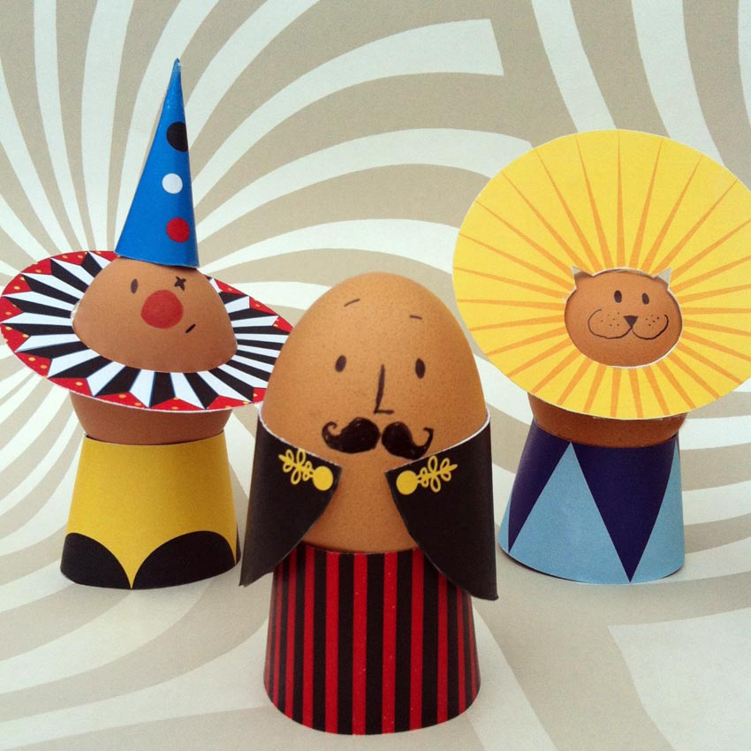
Decorate an egg as a
Book character competition!
In place of our Easter Bonnet competition which had to be cancelled at the end of term, we would like to invite you to take time over the holidays to decorate an egg for our new competition, in aid of our Playground refurbishment project.
Rules:
- Any child can enter, from another school if they wish
- Eggs will be judged in 3 categories – Early Years, KS1 (Class 1) and KS2 (Class 2). If any older children would like to enter, we will make another category
- It costs £2.00 per entry, or any amount you wish to donate above this (it’s in a good cause!)
- Entries must be brought to school on the morning of Tuesday 26th April
- Judging will take place in the afternoon and prizes will be awarded at the end of the day
- Eggs must be dressed as a Book Character and be labelled with the name of the character, the name of the child and their class
- Extra points will be given for funny names with puns on eggs!

