

Whitley Chapel C of E First
Attendance Policy
2025-2026

Friendship, Community, Faith

Whitley Chapel C of E First School

Attendance Policy

Friendship, Community, Faith

Introduction
Regular and punctual school attendance is essential. Pupils need to attend school consistently to benefit from the full educational opportunities available by law. Whitley Chapel C of E First School recognises its responsibility to ensure pupils attend school on time and have access to learning for the maximum number of days and hours.
This policy applies to all children registered at the school and is made available to all parents/carers via the school website. It is written in line with relevant Children Acts, Education Acts, Regulations, and DfE guidance, as well as Local Authority guidance.
Although parents/carers have the legal responsibility for ensuring their child’s attendance, the Headteacher and Governors work with other professionals and agencies to support good attendance.
Children who are persistently late or absent quickly fall behind academically. A child with 90% attendance over a year will miss approximately two terms of learning over their time at first school.

Aims and Objectives
This policy ensures that staff and governors are aware of the actions necessary to promote good attendance.
Through this policy, we aim to:
- Improve pupils’ achievement through high attendance and punctuality.
- Achieve a minimum of 97% attendance for all children, except those with chronic health issues.
- Create a school culture where attendance and punctuality are valued.
- Raise awareness among parents, carers, and pupils of the importance of uninterrupted attendance.
- Include Nursery and Reception children to promote good habits early.
- Work in partnership with pupils, parents, staff, and the Education Welfare Service (EWS) to ensure pupils realise their potential.
- Promote a safe, secure, and welcoming environment, encouraging pupils’ sense of responsibility.
- Monitor attendance consistently and recognise achievement while addressing difficulties.

Promoting Good Attendance
We encourage good attendance and punctuality by:
- Raising awareness among staff, parents, and pupils.
- Ensuring parents understand their responsibilities.
- Helping children develop life skills to take responsibility for attendance.
- Maintaining clear communication with parents, pupils, staff, and governors.
- Identifying, reporting, and reviewing poor attendance and persistent lateness.
- Supporting pupils experiencing difficulties affecting attendance.
- Following up all non-attendance.

Definitions
Authorised Absence
- A child is absent for a legitimate reason with notification from a parent/carer (e.g., illness).
- Only the school can authorise absences; parental support alone does not automatically authorise absence.
Unauthorised Absence
- Absences without school permission are unauthorised, even if supported by parents.

Procedures
We undertake the following to support good attendance:
- Maintain accurate registration and attendance data.
- Communicate attendance procedures and expectations clearly.
- Keep systematic daily records of absence and lateness.
- Follow up unexplained absences or lateness.
- Inform parents of authorised and unauthorised absences.
- Discourage holidays during term time.
- Work with parents to improve attendance.
- Refer persistent attendance issues to the Educational Welfare Service.
- Report attendance statistics to Northumberland LA and the DfE as requested.
- Ensure staff raise concerns with the Headteacher.

Responsibilities
Class Teacher
- Monitor class and individual attendance.
- Identify poor attendance or unusual patterns.
- Inform the Headteacher of concerns and follow up actions.
- Emphasise the importance of punctuality.
- Discuss attendance at parent consultation evenings if necessary.
Headteacher
- Monitor overall attendance trends.
- Contact families with attendance concerns.
- Arrange meetings to discuss attendance issues.
- Make referrals to the EWS.
- Celebrate good attendance via assemblies and certificates.
Administration Staff
- Record attendance accurately in Google 360/SIMS.
- Take messages from parents regarding absence.
- Contact parents of absent children without notification.
- Record late arrivals and early departures.
- Report anomalies or concerns to the Headteacher.
- Send standard letters regarding attendance.
Parents/Carers
- Ensure regular and punctual attendance.
- Notify the school by 9am on the first day of absence.
- Provide evidence for medical absences.
- Make requests for authorised absence only if necessary.
- Communicate promptly about reluctance to attend.

Registration and Lateness
- School opens at 8:50am; doors close at 9:00am.
- Pupils arriving after 9:00am use the front door and are marked late (Code L) until 9.10am
- Arrival after 9:10am is an unauthorised absence for the morning unless a valid reason is given by a parent/carer

Other register codes are as follows -

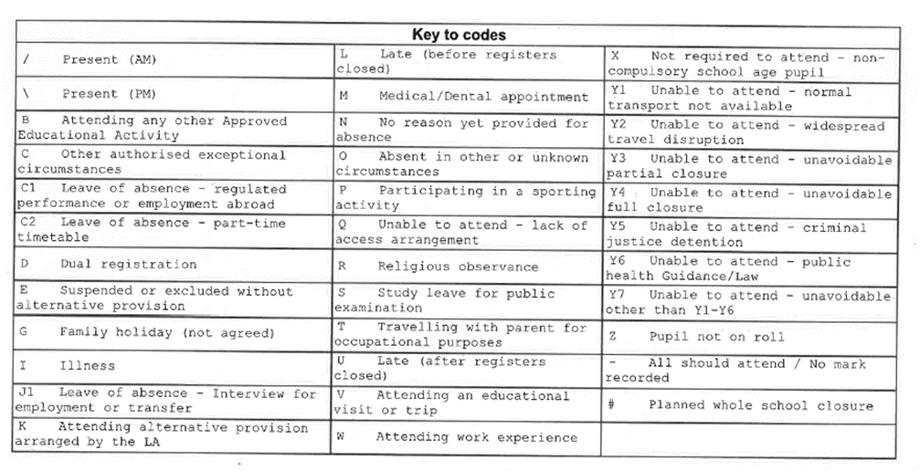

- Registers are legal documents, completed by 9am (morning) and at 1pm (afternoon), and are preserved for three years.

Absences
- Parents must provide the reason for absence.
- Unexplained absences result in letters requesting clarification; failure to respond leads to unauthorised absence (Code O).
- Medical absences require proof from appointments, prescription, or doctor’s note.

Leave of Absence and Term-Time Holidays
- Headteachers may only authorise leave for exceptional circumstances.
- Each application is considered individually, and the number of days authorised is at the Headteacher’s discretion.
- Examples of exceptional circumstances:
  - One-off family events (e.g., special anniversary, parent wedding)
  - Funerals requiring travel
  - Receiving a special award necessitating travel
  - New job opportunities requiring family relocation
  - Parents in the Armed Forces (specific conditions)
- Holidays due to cost or preference are not exceptional.

Penalty Notices

Under the national rules, all schools are required to consider a fine when a child has missed 10 or more sessions (5 days) for unauthorised reasons. The fine for school absences across the country will be £80 if paid within 21 days, or £160 if paid within 28 days. Fine is per parent.
Religious Events
Pupils requesting leave for religious events must complete a Leave of Absence Form (Appendix 1).

Monitoring Attendance
- Attendance data is maintained in SIMS by the office manager.
- Regular meetings with the Headteacher review attendance trends.
- Attendance is reported to the Governing Body at termly meetings.
- The school works collaboratively with families to identify and remove barriers to attendance, in line with DfE guidance (Working Together to Improve Attendance, August 2024).

Document Details
Last Ratification - November 2025
Next Ratification - November 2026


Appendix 1

Whitley Chapel C of E First School
REQUEST FOR LEAVE OF ABSENCE - DURING TERM TIME
Education (Pupil Registration) (England) Regulations 2006
Education (Pupil Registration) (England) (Amendment) Regulations 2013
The 2013 amendments to the 2006 regulations explain clearly that Head Teachers may not grant any leave of absence during term time unless there are exceptional circumstances. Head Teachers should also determine the number of school days a child can be away from school if leave is granted.

Name of pupil
Date of birth
Address
Tutor/Year group
Contact Numbers
Name of sibling/s & school attended

I request permission for my child to be granted leave of absence from school between:

First Day of Absence
Last Day of Absence
Total School Days

Please fully explain the exceptional circumstances relating to the leave of absence you would like the Head Teacher to consider. (Continue on a separate sheet if necessary).Any documentation supporting exceptional circumstances MUST be provided at the time of application

Declaration
I have read and understood the information regarding leave of absence during term time, unauthorised absence, Penalty Notices and prosecution. I am aware of the possible consequences should I take my child on leave of absence without the prior authorisation of the Head Teacher.

Name of parent
Address

Name of parent
Address

Signature……………………………………………… Date……………………

Signature……………………………………………… Date……………………

